

**Agentic AI and Marketing:   
Key Trends and Emerging Topics**

Agentic AI is rapidly becoming the centerpiece of innovation in marketing and adtech, promising to transform how brands collaborate, optimize campaigns, and navigate the increasingly complex digital landscape. Here’s a quick summary of the latest topics and trends shaping this evolving space.

**Agentic AI: From Automation to Autonomy**

Traditional AI in advertising has long focused on automation-optimizing bids, targeting, and creative at scale. Agentic AI, by contrast, introduces a new paradigm: AI systems that can reason contextually, interpret intent, and autonomously execute multi-step tasks. These agentic systems move beyond mere tools to become collaborators, capable of adapting dynamically to shifting campaign goals and data inputs.

This evolution enables agentic AI to:

* Interpret campaign briefs and adapt strategies on the fly
* Navigate complex workflows with minimal human input
* Remain aligned with brand safety and strategic oversight

*Source:* [*What Is Agentic AI? Complete Guide | TechTarget*](https://www.techtarget.com/searchenterpriseai/definition/agentic-AI)

**Solving Data Collaboration and Fragmentation**

A core challenge in digital marketing is data fragmentation. Brands operate across numerous platforms-search, social, DSPs, CTV, retail media-each with its own data silos and measurement standards. Agentic AI is positioned to address this by:

* Unifying workflows across channels
* Providing real-time feedback and optimization recommendations
* Connecting disparate data sources for holistic insights

This is particularly crucial as privacy regulations tighten and third-party identifiers become less reliable, with cookie-based and ID-based matching now covering only a fraction of the open web.

**Secure Data Collaboration Frameworks**

Agentic AI acts as a privacy-preserving intermediary between advertisers, publishers, and data partners:

* Uses cryptographic techniques like multi-party computation to analyze combined datasets without exposing raw data[1](https://www.linkedin.com/pulse/agentic-ai-could-solve-data-collaborations-challenges-alikeaudience-ixkqc)[7](https://equativ.com/blog/articles/agentic-ai-the-next-advertising-game-changer/)
* Maintains data lineage tracking through automated metadata tagging, recording every transformation and access event[3](https://www.decube.io/post/agentic-ai-metadata-management)[6](https://www.alation.com/blog/data-governance-for-ai-agents-what-you-need-to-know/)
* Implements dynamic access controls that adapt to changing compliance requirements (GDPR, CCPA)[8](https://www.xenonstack.com/blog/agentic-ai-analytics-governance-data-trust)[6](https://www.alation.com/blog/data-governance-for-ai-agents-what-you-need-to-know/)

**Intelligent Audience Segmentation**

AI agents enhance targeting through:

* Real-time behavioral analysis: Processes first-party data streams to identify micro-segments based on:

* Cross-platform unification: Resolves identities across walled gardens while maintaining privacy through:

| **Technique** | **Benefit** |
| --- | --- |
| **Federated learning** | **Trains models on decentralized data** |
| **Differential privacy** | **Adds statistical noise to protect individuals** |

* Predictive lookalike modeling: Agents continuously refine audiences using reinforcement learning, achieving 22% higher conversion rates in recent trials[5](https://infillion.com/blog/from-automation-to-autonomy-how-agentic-ai-is-rewriting-the-rules-of-adtech/)[7](https://equativ.com/blog/articles/agentic-ai-the-next-advertising-game-changer/)

**Compliance Automation**

Agentic systems embed regulatory requirements into their operations:

* Automated data masking:

* Self-auditing workflows:
  1. Check data usage against consent records
  2. Validate processing purposes
  3. Generate compliance reports[6](https://www.alation.com/blog/data-governance-for-ai-agents-what-you-need-to-know/)[8](https://www.xenonstack.com/blog/agentic-ai-analytics-governance-data-trust)
* Ethical AI guardrails:Monitors for bias in targeting parameters using fairness metrics like: ****[4](https://smartyads.com/blog/the-rise-of-agentic-AI)[7](https://equativ.com/blog/articles/agentic-ai-the-next-advertising-game-changer/)

**Agentic AI as the Glue for Composable Marketing Stacks**

Composable, interoperable environments are becoming the new standard. Agentic AI thrives in these settings, where it can access diverse data and tools, enabling:

* Real-time campaign optimization
* Dynamic creative testing and budget reallocation
* Seamless integration with existing marketing technology stacks1

**Use Cases of Agentic AI in Marketing Campaigns**

Agentic AI is transforming marketing by automating complex tasks, delivering hyper-personalized experiences, and enabling real-time campaign optimization. Here are some concrete examples and use cases from leading companies and platforms that illustrate how agentic AI is being successfully deployed in marketing:

**1. AI Campaign Managers in Retail and Consumer Brands**

* Major consumer brands are leveraging agentic AI systems as campaign managers. These AI agents monitor live campaign data-such as click-through rates and conversions-and autonomously adjust budgets, bids, and audience targeting in real-time. This ensures campaigns remain effective without constant manual intervention, leading to higher ROI and more agile marketing responses[6](https://trengo.com/blog/agentic-ai-examples)[7](https://hightouch.com/blog/agentic-ai-in-marketing).

**2. Hyper-Personalization at Scale**

* E-commerce companies use agentic AI to create true 1:1 personalization. Instead of segmenting audiences into broad groups, agentic AI dynamically tailors messaging, imagery, and offers for each individual based on their behavior, preferences, and engagement history. This results in thousands of personalized ad variations, significantly boosting engagement and conversion rates[7](https://hightouch.com/blog/agentic-ai-in-marketing)[5](https://www.singlegrain.com/artificial-intelligence/how-agentic-ai-is-revolutionizing-digital-marketing/).

**3. Automated Customer Journey Mapping**

* Businesses are deploying agentic AI to map and optimize the customer journey across multiple channels. The AI tracks interactions, analyzes behavior, and delivers tailored messages-such as personalized emails or timely reminders-to engage customers at the right moment, increasing retention and lifetime value[6](https://trengo.com/blog/agentic-ai-examples)[7](https://hightouch.com/blog/agentic-ai-in-marketing).

**4. Real-Time Campaign Optimization for Paid Media**

* Companies running multi-platform ad campaigns (across Google, Meta, LinkedIn, etc.) use agentic AI to automate budget allocation, bid adjustments, and creative testing. The AI continuously refines targeting and synchronizes ad placements, ensuring optimal performance and freeing marketers to focus on strategy[7](https://hightouch.com/blog/agentic-ai-in-marketing)[5](https://www.singlegrain.com/artificial-intelligence/how-agentic-ai-is-revolutionizing-digital-marketing/).

**5. Enhanced Customer Engagement with Conversational AI**

* Brands are implementing agentic AI-powered chatbots and virtual assistants to provide 24/7 customer support. These systems can answer queries, offer personalized recommendations, and even predict customer needs based on previous interactions, leading to improved satisfaction and increased sales[5](https://www.singlegrain.com/artificial-intelligence/how-agentic-ai-is-revolutionizing-digital-marketing/)[6](https://trengo.com/blog/agentic-ai-examples).

**6. Advanced Sentiment Analysis for Social Media**

* Marketers use agentic AI to monitor social media in real time, analyzing conversations and sentiment about their brand or products. This allows for rapid response to emerging trends or crises and provides valuable competitive insights[5](https://www.singlegrain.com/artificial-intelligence/how-agentic-ai-is-revolutionizing-digital-marketing/).

**7. Automated Content Creation and SEO Optimization**

* Content-heavy brands leverage agentic AI to generate, optimize, and distribute content at scale. The AI identifies high-impact keywords, analyzes competitor strategies, and produces SEO-optimized articles and visuals, improving organic reach and search rankings[7](https://hightouch.com/blog/agentic-ai-in-marketing).

**Notable Industry Examples:**

* While many companies keep their agentic AI strategies proprietary, platforms like Salesforce have highlighted how consumer goods brands use AI agents for sales, key account management, and retail execution, transforming both customer engagement and operational efficiency[4](https://www.salesforce.com/blog/how-brands-use-agentic-ai/).
* AI marketing agencies such as Single Grain offer agentic AI-driven campaign management and personalization solutions to clients, demonstrating measurable improvements in campaign performance and customer satisfaction[5](https://www.singlegrain.com/artificial-intelligence/how-agentic-ai-is-revolutionizing-digital-marketing/).

**Results and Impact**

Early adopters report:

* 40% faster data collaboration cycles[1](https://www.linkedin.com/pulse/agentic-ai-could-solve-data-collaborations-challenges-alikeaudience-ixkqc)[5](https://infillion.com/blog/from-automation-to-autonomy-how-agentic-ai-is-rewriting-the-rules-of-adtech/)
* 18% improvement in audience quality scores[2](https://hightouch.com/blog/agentic-ai-in-marketing)[4](https://smartyads.com/blog/the-rise-of-agentic-AI)
* 100% audit readiness for data processing activities[6](https://www.alation.com/blog/data-governance-for-ai-agents-what-you-need-to-know/)[8](https://www.xenonstack.com/blog/agentic-ai-analytics-governance-data-trust)

By combining autonomous operation with embedded governance controls, agentic AI creates a new paradigm where data utility and compliance coexist through intelligent automation rather than manual oversight.

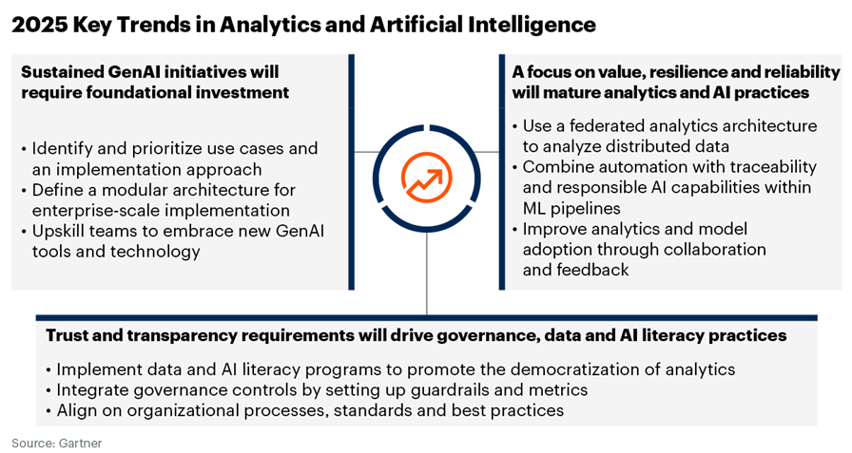

**Looking Ahead**

*Source:* [*AI In Advertising: Exploring AI-Powered Tools and Automation - Flying V Group*](https://www.flyingvgroup.com/ai-in-advertising/)

With AI now ubiquitous in content creation and campaign management, the next competitive frontier is leveraging agentic AI on proprietary first-party data. Brands that can securely harness their unique data assets for hyper-personalized experiences will stand out in a crowded marketplace.

Agentic AI is not just a technological upgrade-it’s a fundamental shift in how marketing organizations operate. As agentic systems become more capable and composable platforms proliferate, the industry is moving toward a future where AI-powered agents orchestrate campaigns, optimize spending, and enable deep collaboration-while humans provide strategic direction and oversight.

The momentum behind agentic AI is real, and brands that embrace this shift will be better positioned to navigate the challenges of privacy, fragmentation, and ever-evolving consumer expectations.

About Precise.ai

Precise is a leader in data verification and secure collaboration, specializing in Proof of Data technology to ensure transparency, trust, and compliance. Through blockchain-backed proof methodologies, Precise provides data owners with an immutable record of accuracy, lineage, and responsible data use. In addition to data verification, Precise enables privacy-preserving data collaboration through federated machine learning, allowing organizations to extract insights and drive value while keeping sensitive data protected and decentralized. By establishing verifiable data integrity and privacy-first data activation, Precise empowers businesses to confidently leverage their data while maintaining compliance and accountability.  Contact us at [info@precise.ai](mailto:info@precise.ai).